NAME : S.MATHESWARI

ROLL NO : 727722EUIT086

DEPT : B.TECH.IT (B)

DAY – 7

EXERCISE – 1

package day7;

import org.openqa.selenium.WebDriver;

import org.openqa.selenium.chrome.ChromeDriver;

import org.openqa.selenium.chrome.ChromeOptions;

import org.testng.annotations.Test;

import org.testng.Assert;

import io.github.bonigarcia.wdm.WebDriverManager;

public class ex1{

@Test

public void pro1() {

WebDriverManager.chromedriver().setup();

WebDriver driver;

ChromeOptions co=new ChromeOptions();

co.addArguments("--remote-allow-origins=*");

driver=new ChromeDriver(co);

driver.navigate().to("https://demo.wpeverest.com/user-registration/guest-registration-form/");

String expect="Guest Registration Form – User Registration";

String actual =driver.getTitle();

Assert.assertEquals(expect, actual);

System.out.print("true");

}

}

OUTPUT :

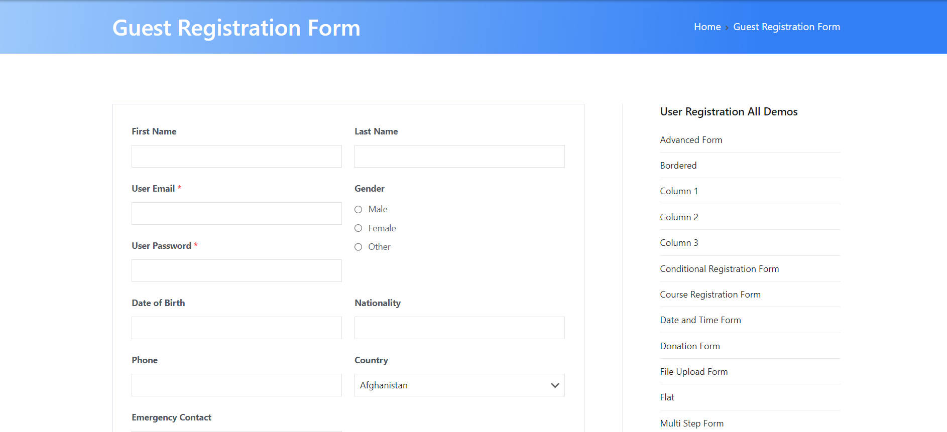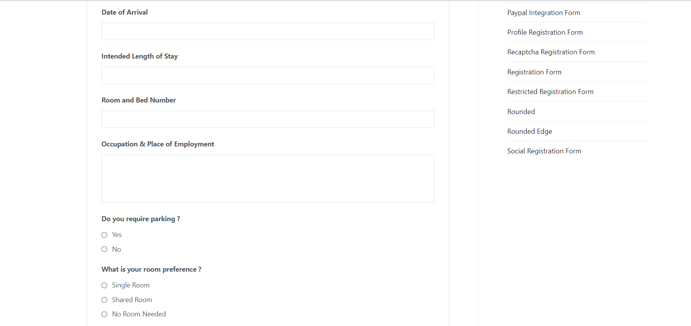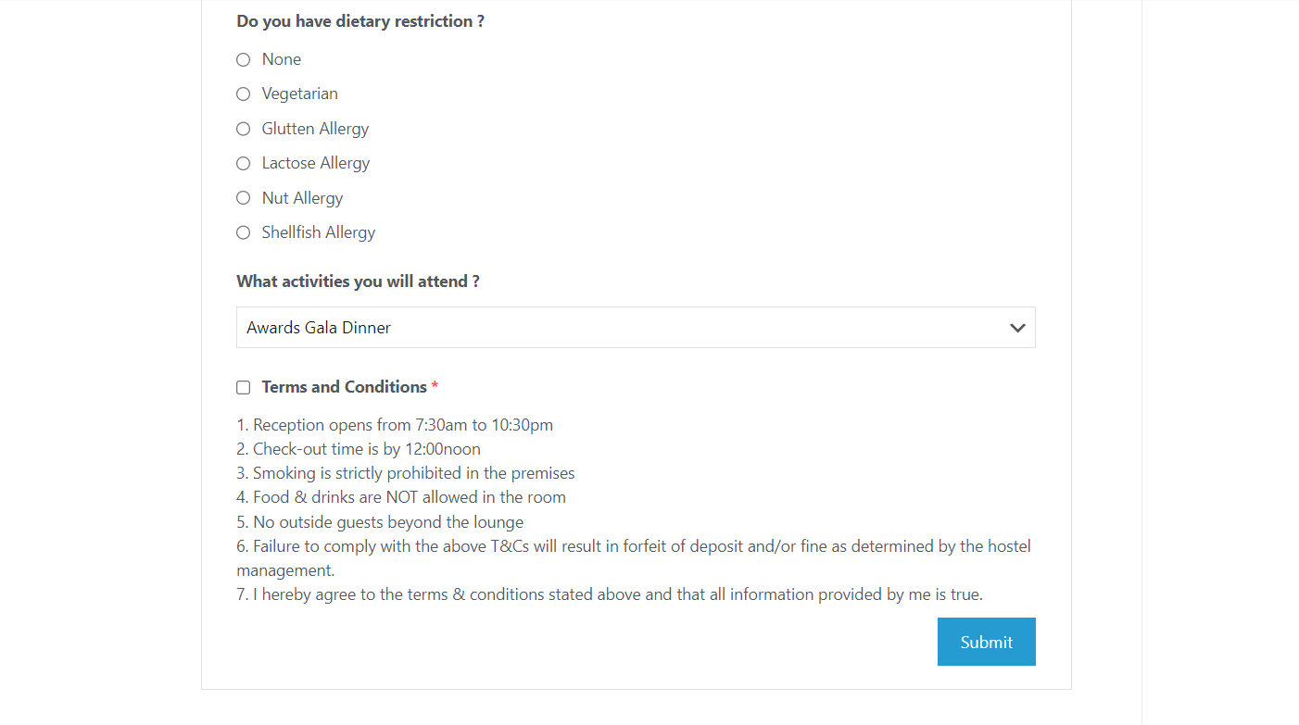

EXERCISE – 2

package day7;

import org.testng.Assert;

import org.testng.annotations.Test;

public class ex2 {

int a=12,b=10;

@Test(priority=3)

public void add() {

int c=a+b;

System.out.println("Addition: "+c);

Assert.assertEquals(c, 22);

}

@Test(priority=2)

public void sub() {

int c=a-b;

System.out.println("Substraction: "+c);

Assert.assertEquals(c, 2);

}

@Test(priority=1)

public void mul() {

int c=a*b;

System.out.println("Multiplication: "+c);

Assert.assertEquals(c, 120);}

@Test(priority=4)

public void div() {

int c=a/b;

System.out.println("Divison: "+c);

Assert.assertEquals(c, 1);

}

}

OUTPUT :

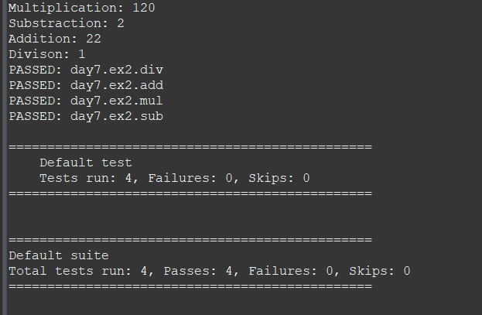

EXERCISE 3:

package day7;

import org.testng.annotations.Test;

import io.github.bonigarcia.wdm.WebDriverManager;

import org.testng.annotations.BeforeMethod;

import org.openqa.selenium.By;

import org.openqa.selenium.WebDriver;

import org.openqa.selenium.chrome.ChromeDriver;

import org.openqa.selenium.chrome.ChromeOptions;

import org.testng.Assert;

import org.testng.annotations.AfterMethod;

public class ex3{

WebDriver driver;

*@Test*

public void print() throws InterruptedException {

driver.get("https://opensource-demo.orangehrmlive.com/web/index.php/auth/login");

Thread.*sleep*(3000);

driver.findElement(By.*xpath*("//input[@name='username']")).sendKeys("Admin");

driver.findElement(By.*xpath*("//input[@name='password']")).sendKeys("admin123");

driver.findElement(By.*xpath*("//*[@id=\"app\"]/div[1]/div/div[1]/div/div[2]/div[2]/form/div[3]/button")).click();

Thread.*sleep*(3000);

String text=driver.findElement(By.*xpath*("//h6[@class=\'oxd-text oxd-text--h6 oxd-topbar-header-breadcrumb-module\']")).getText();

String expText="Dashboard";

Assert.*assertEquals*(text, expText);

}

*@BeforeMethod*

public void beforeMethod() {

ChromeOptions co=new ChromeOptions();

co.addArguments("--remote-allow-origins=*");

WebDriverManager.*chromedriver*().setup();

driver=new ChromeDriver(co);

}

*@AfterMethod*

public void afterMethod() **}}**

OUTPUT :

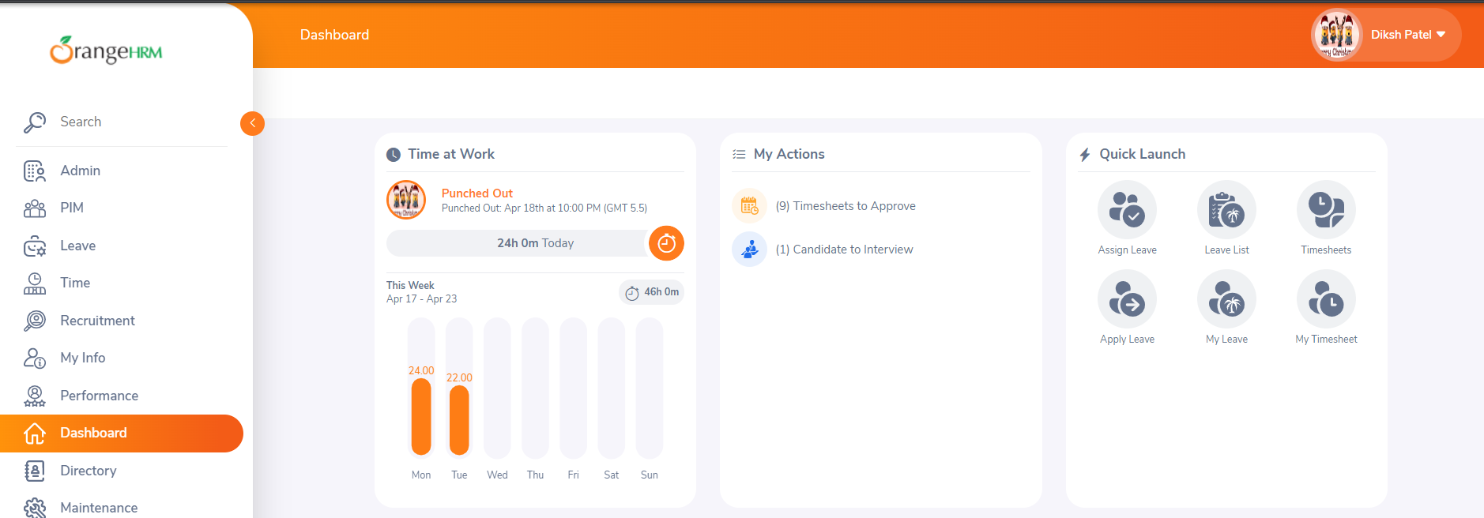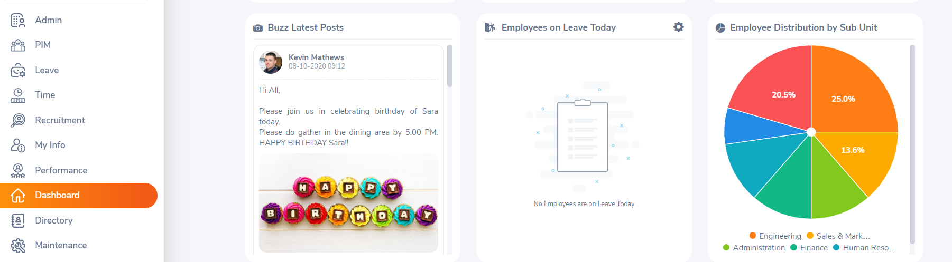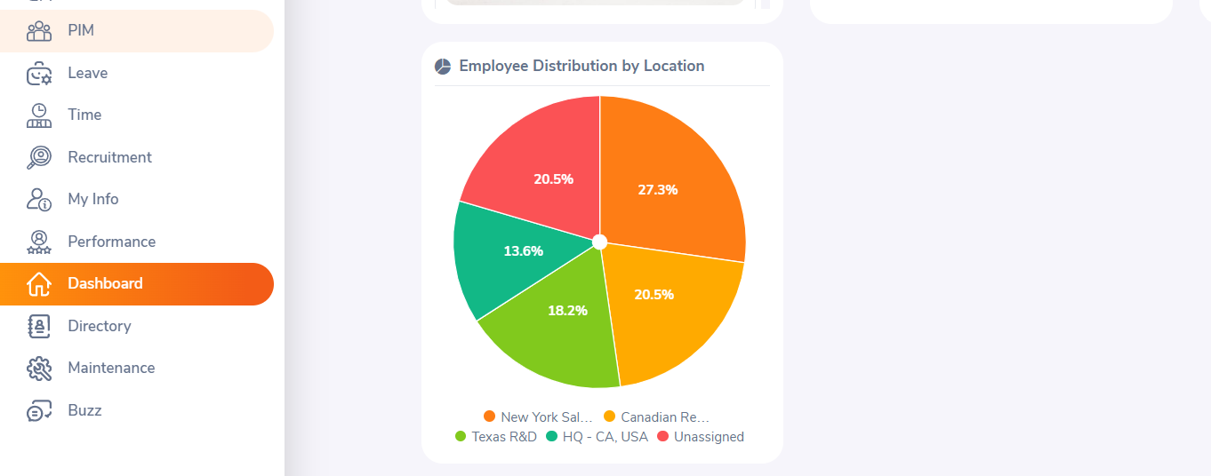

EXERCISE 4:

package day7;

import org.testng.annotations.Test;

import io.github.bonigarcia.wdm.WebDriverManager;

import org.openqa.selenium.By;

import org.openqa.selenium.WebDriver;

import org.openqa.selenium.WebElement;

import org.openqa.selenium.chrome.ChromeDriver;

import org.openqa.selenium.chrome.ChromeOptions;

import org.testng.Assert;

import org.testng.annotations.BeforeSuite;

public class ex4 {

WebDriver driver;

*@BeforeSuite*

void init() {

WebDriverManager.*chromedriver*().setup();

ChromeOptions co=new ChromeOptions();

co.addArguments("--remote-allow-origins=*");

driver=new ChromeDriver(co);

}

*@Test*

void Test1() throws InterruptedException

{

String url="https://opensource-demo.orangehrmlive.com/web/index.php/auth/login";

driver.get(url);

Thread.*sleep*(3000);

WebElement uname=driver.findElement(By.*name*("username"));

WebElement pwd=driver.findElement(By.*name*("password"));

WebElement submit=driver.findElement(By.*xpath*("//*[@id=\"app\"]/div[1]/div/div[1]/div/div[2]/div[2]/form/div[3]/button"));

uname.sendKeys("Admin");

pwd.sendKeys("admin123");

submit.click();

String url1="https://opensource-demo.orangehrmlive.com/web/index.php/dashboard/index";

String actualurl=driver.getCurrentUrl();

Assert.*assertEquals*(url1, actualurl);

}

*@Test*(dependsOnMethods="Test1")

void Test2() throws InterruptedException

{

Thread.*sleep*(3000);

driver.findElement(By.*xpath*("//*[@id=\"app\"]/div[1]/div[1]/header/div[1]/div[2]/ul/li/span/p")).click();

Thread.*sleep*(3000);

driver.findElement(By.*xpath*("//*[@id=\"app\"]/div[1]/div[1]/header/div[1]/div[2]/ul/li/ul/li[4]/a")).click();

Thread.*sleep*(3000);

WebElement logout=driver.findElement(By.*linkText*("Logout"));

logout.click();

driver.close();

}

}

**OUTPUT :**

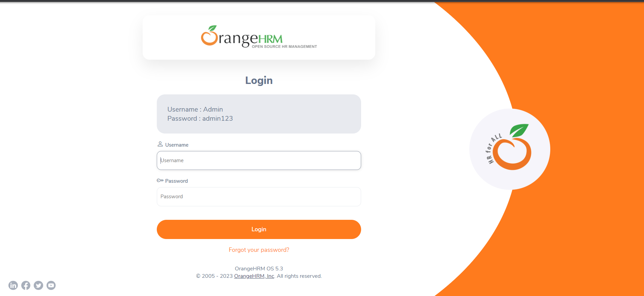

**EXERCISE 5:**

package day7;

import java.util.concurrent.TimeUnit;

import org.openqa.selenium.By;

import org.openqa.selenium.WebDriver;

import org.openqa.selenium.chrome.ChromeDriver;

import org.openqa.selenium.chrome.ChromeOptions;

import org.testng.Assert;

import org.testng.annotations.Test;

import io.github.bonigarcia.wdm.WebDriverManager;

public class ex5 {

*@Test*(groups= {"SmokeTest"})

public void Test1() {

WebDriverManager.*chromedriver*().setup();

WebDriver driver;

ChromeOptions co = new ChromeOptions();

co.addArguments("--remote-allow-origins=*");

driver=new ChromeDriver(co);

driver.get("https://www.godaddy.com/en-in");

driver.manage().window().maximize();

String actualTitle="Domain Names, Websites, Hosting & Online Marketing Tools - GoDaddy IN";

String extractedTitle=driver.getTitle();

Assert.*assertEquals*(actualTitle, extractedTitle);

String actualURL="https://www.godaddy.com/en-in";

String extractedURL=driver.getCurrentUrl();

Assert.*assertEquals*(actualURL, extractedURL);

driver.quit();

driver.manage().timeouts().~~implicitlyWait~~(0, *TimeUnit*.***MILLISECONDS***);

}

*@Test*(groups= {"RegressionTest"})

public void Test2() {

WebDriverManager.*chromedriver*().setup();

WebDriver driver;

ChromeOptions co = new ChromeOptions();

co.addArguments("--remote-allow-origins=*");

driver=new ChromeDriver(co);

driver.get("https://www.godaddy.com/en-in");

driver.manage().window().maximize();

driver.manage().timeouts().~~implicitlyWait~~(3000, *TimeUnit*.***SECONDS***);

driver.findElement(By.*xpath*("//*[@id=\"id-631b049a-e9c0-4d24-8710-c504745206dd\"]/div[2]/div[1]/ul/li[1]/button")).click();

driver.findElement(By.*linkText*("Domain Name Search")).click();

//driver.quit();

}

*@Test*(groups= {"RegressionTest"})

public void Test3() {

WebDriverManager.*chromedriver*().setup();

WebDriver driver;

ChromeOptions co = new ChromeOptions();

co.addArguments("--remote-allow-origins=*");

driver=new ChromeDriver(co);

driver.get("https://www.godaddy.com/en-in");

driver.manage().window().maximize();

driver.manage().timeouts().~~implicitlyWait~~(3000, *TimeUnit*.***SECONDS***);

driver.findElement(By.*xpath*("//*[@id=\"id-631b049a-e9c0-4d24-8710-c504745206dd\"]/div[2]/div[1]/ul/li[1]/button")).click();

driver.findElement(By.*linkText*("Domain Name Search")).click();

String titl=driver.getTitle();

System.***out***.println("Title="+titl);

//driver.quit();

}

}

OUTPUT :

